**Word Problems – ANSWER KEY!**

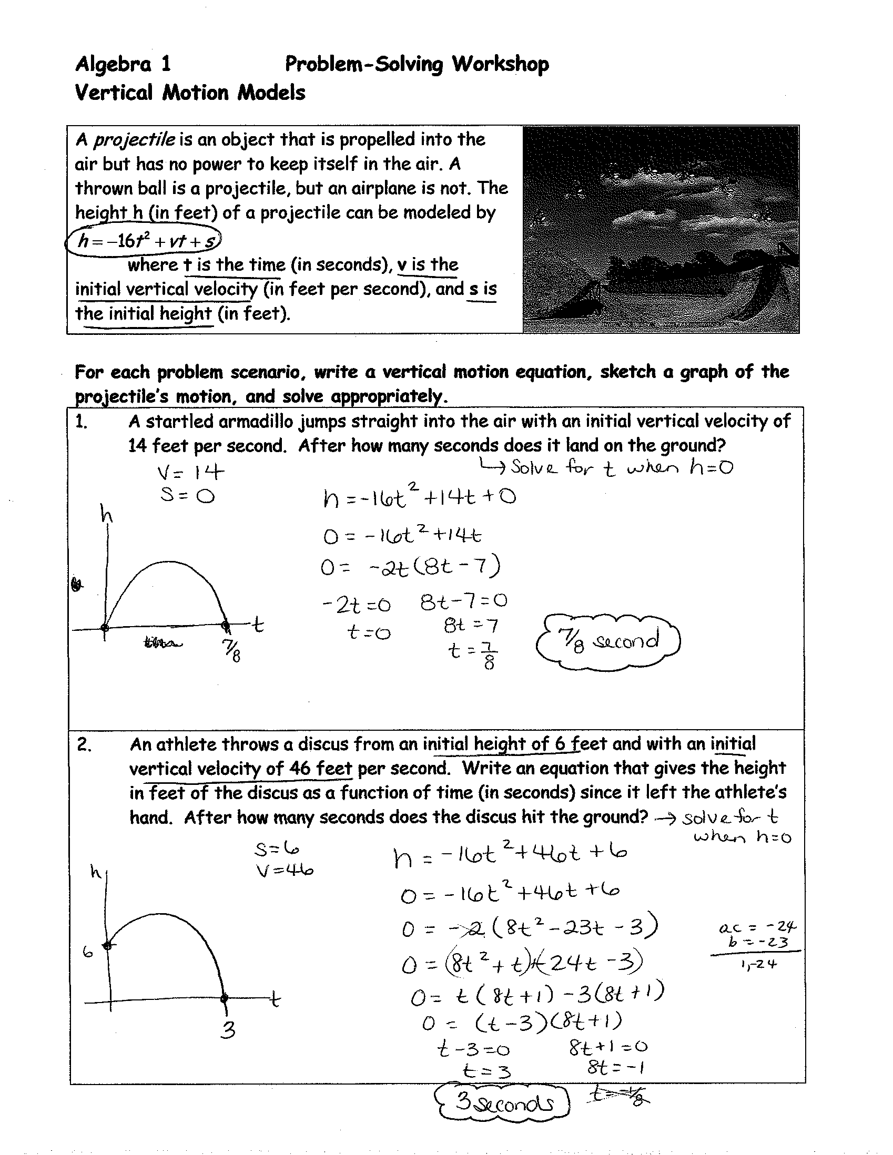

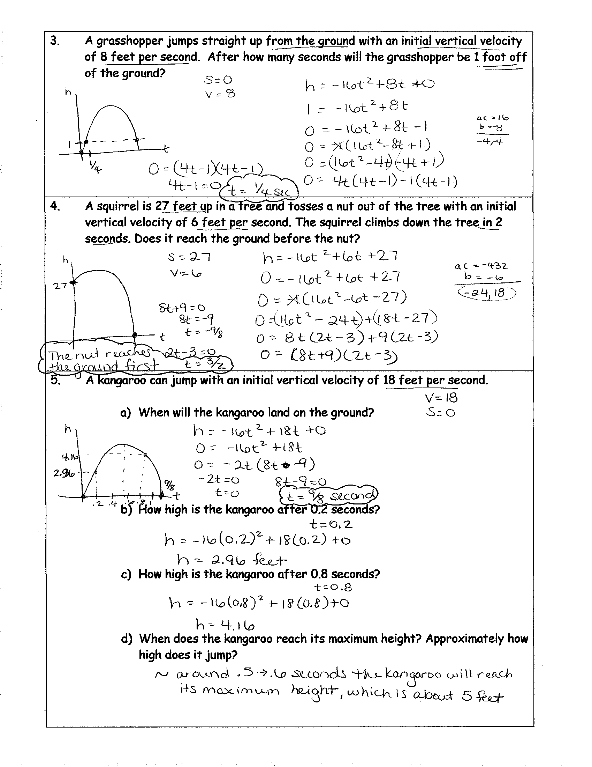

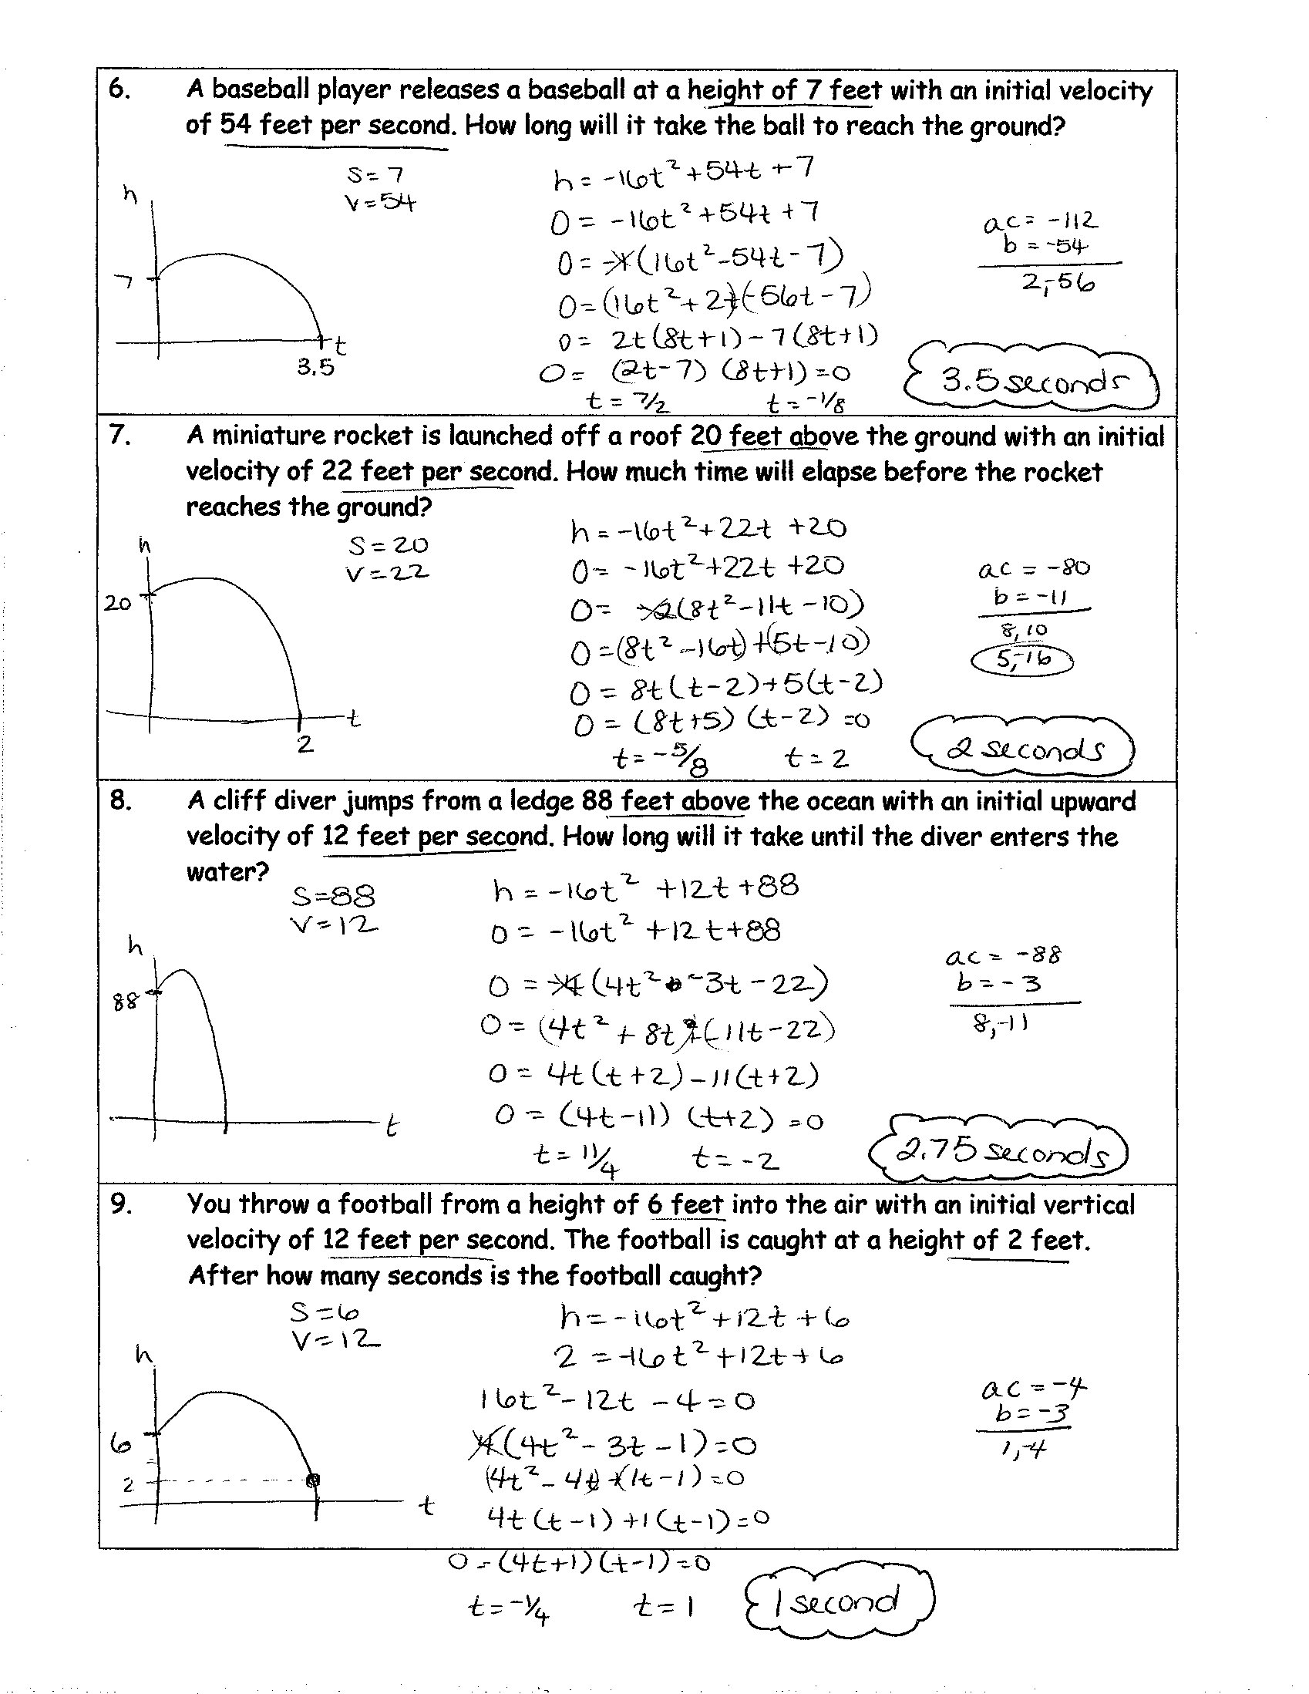

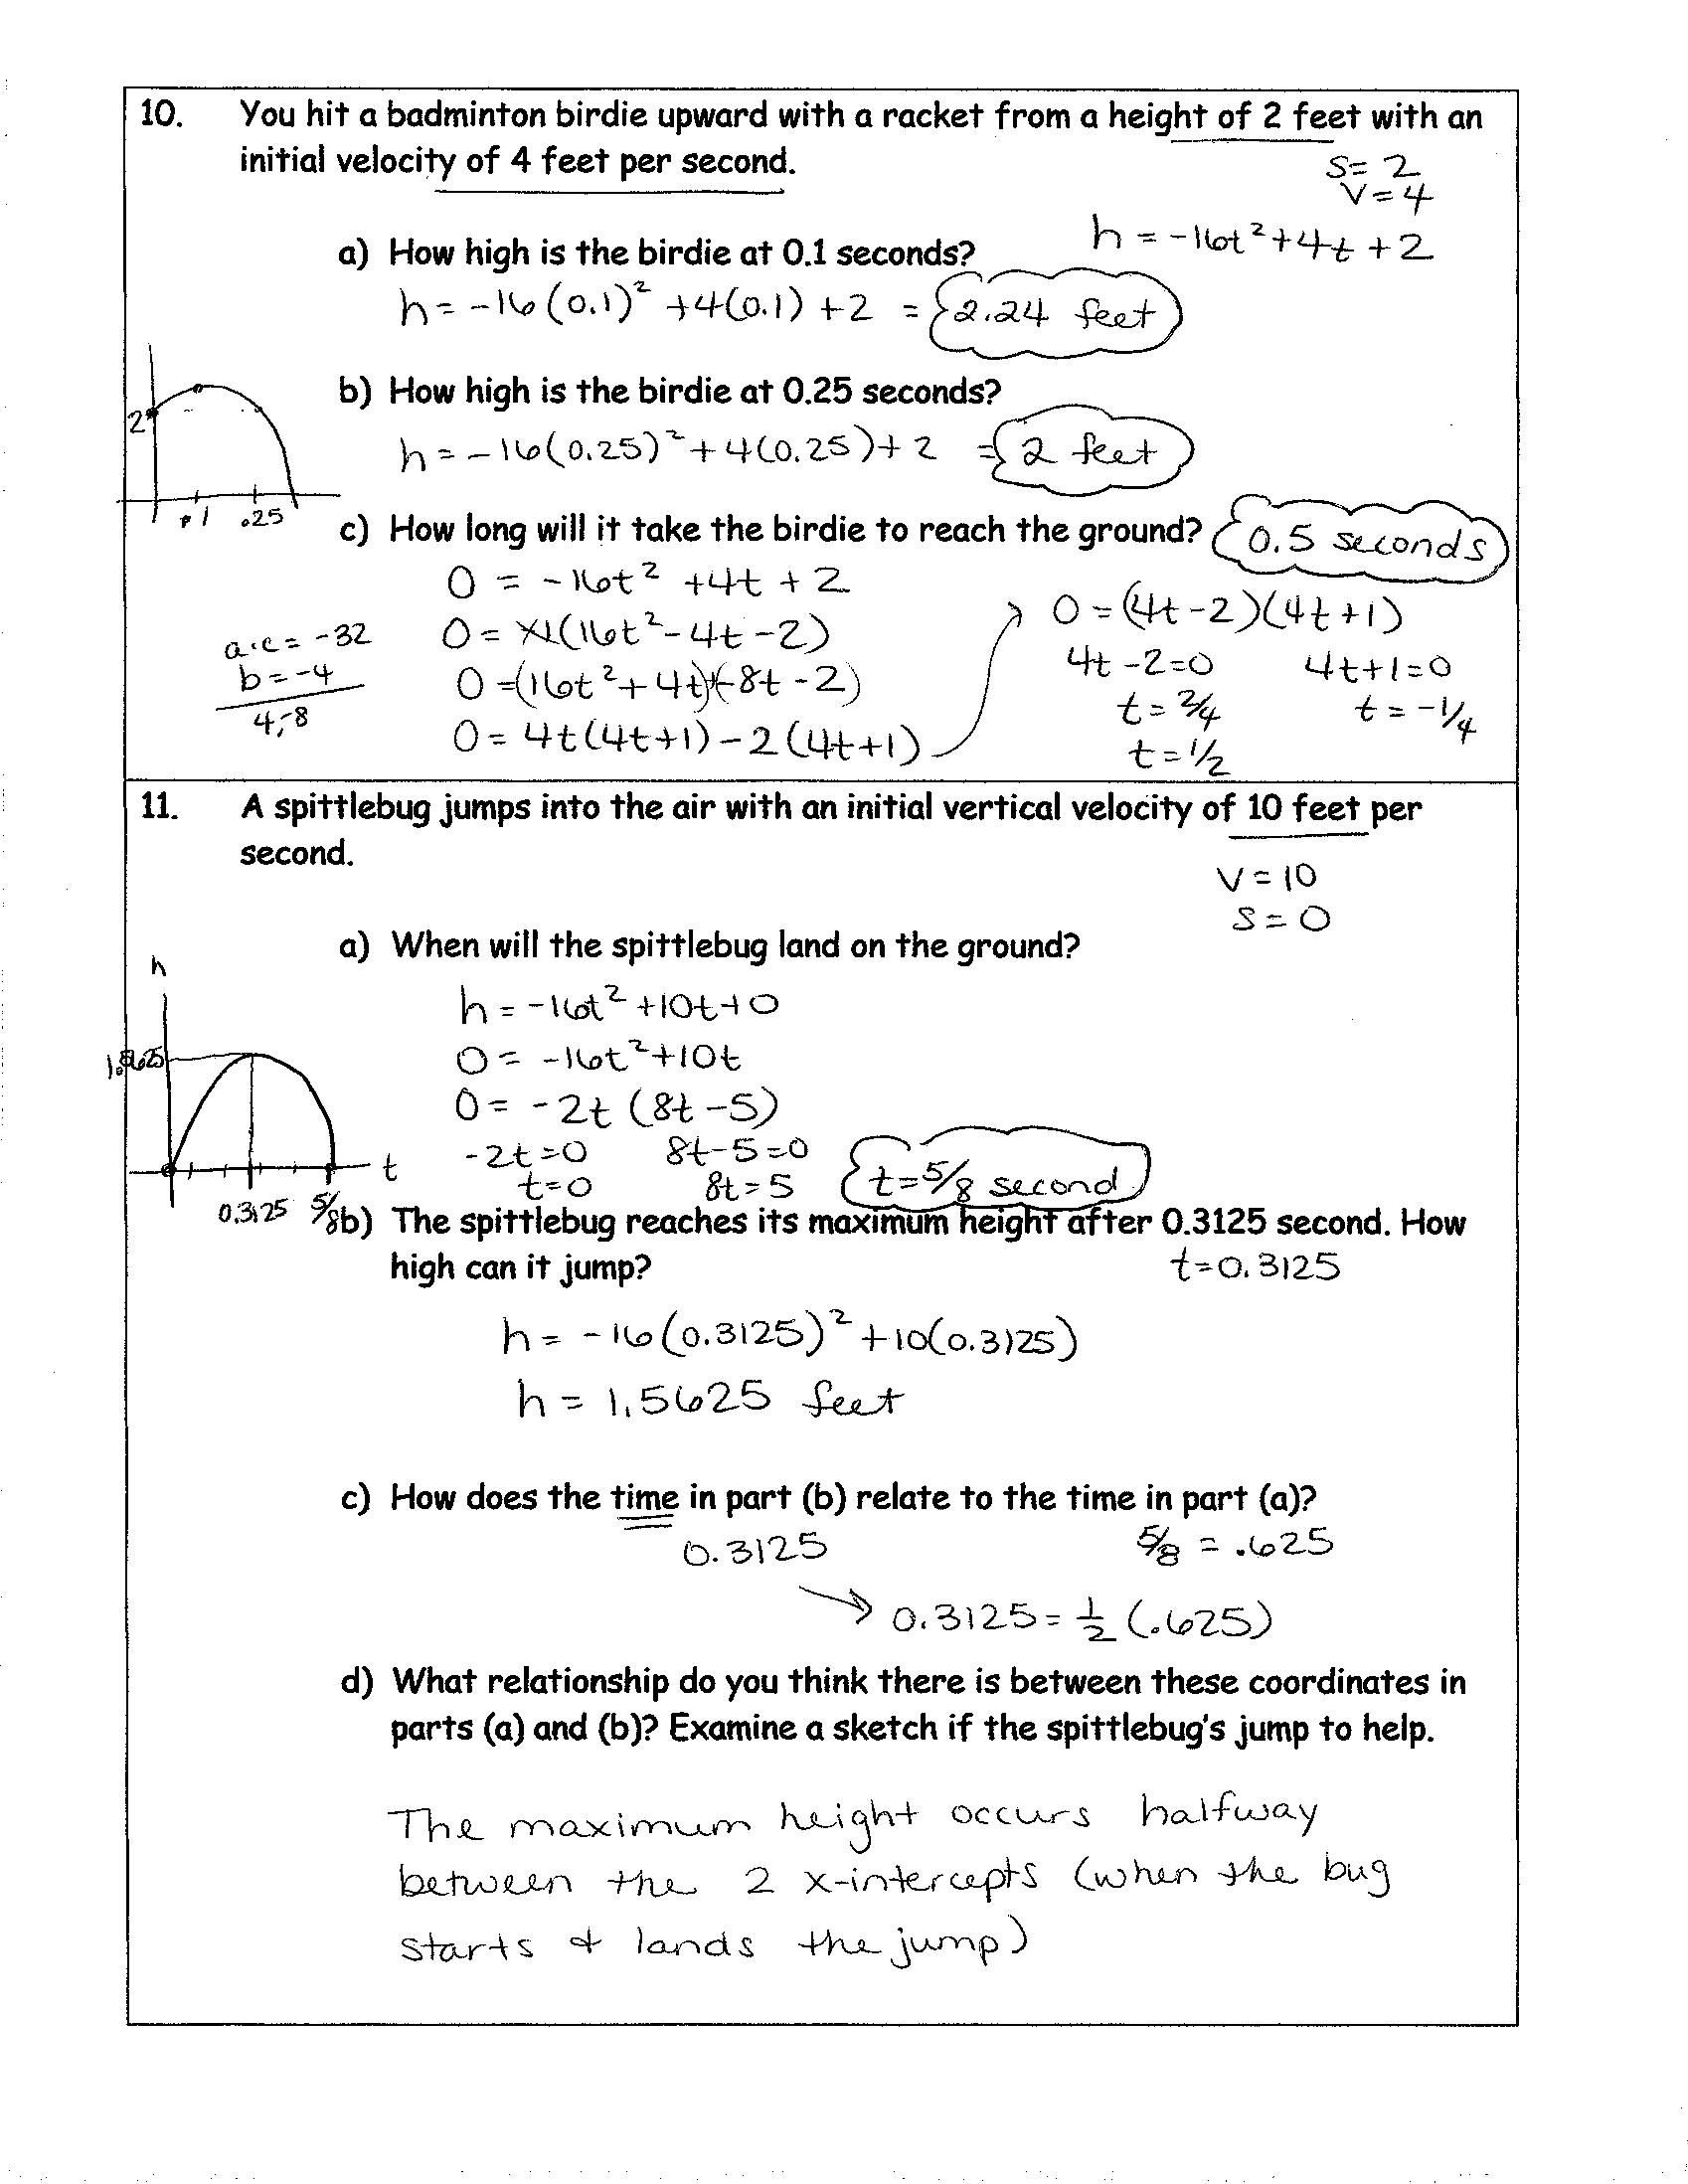

**Vertical Motion Problems – Day 2/3**

**Use the formula: d = rt – 5t2**

**D = distance from the ground, vertical distance – starting point, d = 0  
R = rate (speed)**

**T = time**

1. A football is kicked into the air with an initial upward velocity of 25 m/sec.
   1. Calculate the height after: 2 seconds, 3 seconds

2 seconds – d = 25(2) – 5 (22)

d = 50 – 20

d = 30 m

3 seconds – d = 25(3) – 5 (32)

d = 75 – 45

d = 30 m

* 1. When will it be 20 meters above the ground?

20 = 25t – 5t2

0 = -5t2 + 25t – 20

0 = 5t2 – 25t + 20

0 = 5(t2 – 5t + 4)

0 = 5(t – 4)(t – 1)

T = 1 second and 4 seconds

* 1. When will the ball hit the ground?

0 = 25t - 5t2

0 = 5t(5 – t)

T = 0 and **5 seconds**

**Picture:**

1. A twirler throws a baton with an initial upward velocity of 20 m/sec.
   1. Calculate the height after 2 seconds.

d = 20(2) – 5(22)

d = 40 – 20

d = 20 m

* 1. When will it be 15 meters above where it was thrown?

15 = 20t – 5t2

5t2 – 20t + 15 = 0

5(t2 – 4t + 3) = 0

5(t – 3)( t – 1) = 0

T = 1 and 3 seconds

* 1. When will the baton be back down at the twirler’s level?

0 = 20t – 5t2

0 = 5t( 4 – t)

T = 0 and **4 seconds**

1. Milt Famey, the baseball player, hits a pop fly to the infield. It goes upward with an initial upward velocity of 30 m/sec.
   1. What is its altitude after 2 seconds?

d = 30(2) – 5(22)

d = 60 – 20

d = 40 m

* 1. When is it 25 meters above where it was hit?

25 = 30t – 5t2

5t2 – 30t + 25 = 0

5(t2 – 6t + 5) = 0

5(t – 5)(t – 1) = 0

T = 1 and 5 seconds

* 1. When is it back down?

0 = 30t – 5t2

0 = 5t(6 – t)

T = 0 and **6 seconds**

* 1. The ball is at its highest halfway between the time it is hit (t = 0) and the time it gets back down.
     1. When is it at highest? What is its highest distance?

When = 3 seconds

Distance

d = 30(3) – 5(32)

d = 90 – 45

d = 45 m

1. A cannonball is fired up with an initial upward velocity of 100 m/sec.
2. Calculate its altitude after 3 seconds.

d = 100(3) – 5(32)

d = 300 – 45

d = 255 m

1. At what time(s) will it be 480 meters high?

480 = 100t – 5t2

5t2 – 100t + 480 = 0

5(t2 – 20t + 96) = 0

5(t – 12)(t – 8) = 0

T = **12 and 8 seconds**

1. When does it return to the ground?

0 = 100t – 5t2

0 = 5t(20 – t)

T = 0 and **20 seconds**

1. The cannonball reaches its highest point halfway between the time it was fired (t = 0) and the time it hits the ground.
   * 1. When is it at its highest? How high is at its highest?

When = 10 seconds

How high?

d = 100(10) – 5(102)

d = 1000 – 500

d = 500 m

1. Snoopy is flying in his Sopwith Camel. He fires at the Red Baron. The bullet has an initial upward velocity 120 m/sec.
   1. The Red Baron is 400 meters above Snoopy. When will the bullet first reach his altitude?

400 = 120t – 5t2

5t2 – 120t + 400 = 0

5(t2 – 24t + 80) = 0

5(t – 20)(t – 4) = 0

T = 20 seconds and **4 seconds**

* 1. The bullet misses on the way up. When could it hit the Red Baron on its way back down?

20 seconds

* 1. If the bullet also misses the Red Baron on its way down, when will it be back at the level of Snoopy’s Sopwith Camel?

0 = 120t – 5t2

0 = 5t(24 – t)

T = 0 and **24 seconds**

* 1. If it misses Snoopy on the way back down, when will it hit the ground, 900 meters *below* where it was fired?

-900 = 120t – 5t2

5t2 – 120t – 900 = 0

5(t2 – 24t – 180) = 0

5(t – 30)(t + 6) = 0

T = 30 seconds

1. Suppose that you throw a rock into the air from the top of a cliff. The initial upward velocity is 15 m/sec.
   1. How high will the rock be above the cliff top after 2 seconds?

d = 15(2) – 5(22)

d = 30 – 20

d = 10 meters

* 1. Where will it be after 4 seconds?

d = 15(4) – 5(42)

d = 60 – 80

d = -20 meters, 20 meters below the cliff

* 1. When will it **again** be at the same level you threw it?

0 = 15t – 5t2

0 = 5t(3 – t)

T = 0 and **3 seconds**

* 1. When will hit the water, 50 meters *below* where you threw it?

-50 = 15t – 5t2

5t2 – 15t – 50 = 0

5(t2 – 3t – 10) = 0

5(t – 5)(t + 2) = 0

T = 5 seconds, -2 does NOT work-you can’t have a negative time

1. At the circus, Art Tillery is fired into the air from a cannon on a platform. His initial upward velocity is 7 m/sec.
   1. How high is he above the firing point after 0.6 seconds?

d = 7(.6) – 5(.62)

d = 4.2 – 1.8

d = 2.4 m

* 1. When will he be 2 meters above the firing point?

2 = 7t – 5t2

5t2 – 7t + 2 = 0

(5t – 2)(t – 1) = 0

T = .4 and 1 seconds

* 1. When will he be back at the level of the cannon?

0 = 7t – 5t2

0 = t(7 – 5t)

T = 0 and **1.4 seconds**

* 1. When will he land in the tank of water, 20 m *below* his firing point?

-20 = 7t – 5t2

5t2 – 7t – 20 = 0



Time = 2.82 seconds

1. Wile E. Coyote is standing on a springboard atop a high cliff. Roadrunner drops a boulder on the other end of the springboard, sending Wile up with an initial upward velocity of 45 m/sec.
   1. How high will Wile be after 4 seconds?

d = 45(4) – 5(42)

d = 180 – 80

d = 100 m

* 1. At what *other* time will he be at the same altitude in part (a)?

100 = 45t – 5t2

5t2 – 45t + 100 = 0

5(t2 – 9t + 20) = 0

5(t – 5)(t – 4) = 0

T = 4 and **5 seconds**

* 1. At 4 seconds, was Wile going *up* or *down*? Why?

Up

* 1. When does he again reach the level of the springboard?

0 = 45t – 5t2

0 = 5t(9 – t)

T = 0 and **9 seconds**

* 1. On the way down, Wile misses the cliff! At what time does he land in the river, 120 meters  *below* the top of the cliff?

-120 = 45t – 5t2

5t2 – 45t – 120 = 0

5(t2 – 9t – 24) = 0



Time = 11.15 seconds

1. Chuck throws a rock with an initial upward velocity of 12 m/sec.
   1. How high is it after 0.7 seconds?

d = 12(.7) – 5(.72)

d = 5.95 m

* 1. When will it be 7.2 meters up?

7.2 = 12t – 5t2

5t2 – 12t + 7.2 = 0



1.2 seconds

* 1. At the time in part (b), is it going *up* or *down*? Why?

Neither, it is the max point or highest point, vertex

* 1. When does the rock get back to the ground level?
  2. On the way back down, the rock goes straight down a well, splashing at the bottom 4 seconds after it was thrown. How deep is the well?

d = 12(4) – 5(42)

d = 48 – 80

d = -32 m or 32 m

1. As Al Pine jumps off the end of the ski jump, he has an initial upward velocity of 13 m/sec.
   1. How high will he be 2 seconds after he jumps?

d = 13(2) – 5(22)

d = 26 – 20

d = 6 m

* 1. At what *other* time is he as high as in part (a)?

6 = 13t – 5t2

5t2 – 13t + 6 = 0

(t – 2)(5t – 3) = 0

T = 2, **0.6 seconds**

* 1. At 2 seconds, was Al going *up* or going *down*? Why?

Down – second time at that height

* 1. When is he again at the level of the end of the ski jump?

0 = 13t – 5t2

0 = t(13 – 5t)

T = 0 and **2.6 seconds**

* 1. Al spends a total of 5.2 seconds in the air. How far below the end of the ski jump does he land?

d = 13(5.2) – 5(5.22)

d = 67.6 – 135.2

d = - 67.6 m or 67.6 m below

1. A basketball player shoots a long shot. The ball has an initial upward velocity of 6 m/sec. When it is released, the ball is at the same level as the basket.
   1. After 0.3 seconds, how high is the ball above the basket?

d = 6(.3) – 5(.32)

d = 1.35 m

* 1. The basket is 3 meters above the gym floor. After 0.3 seconds, how high is the ball above the gym floor?

4.35 m

* 1. Assuming that the aim is good, when will the ball go in the basket?

0 = 6t – 5t2

0 = t(6 – 5t)

T = 0, **1.2 seconds**

* 1. The ball is at its highest halfway between the time it is thrown and the time it goes in the basket. What time is this? How is the ball above the gym floor?

time = .6 seconds

d = 6(.6) – 5(.62)

d = 1.8 m….therefore d = 4.8 m

1. In an underhanded volleyball serve, the ball leaves the server’s hand 1 m above the floor. Suppose that its initial upward velocity is 7 m/sec.
   1. How high above the *floor* will it be after 0.3 seconds?

d = 7(.3) – 5(.32)

d = 1.65 m….therefore d = 2.65 m

* 1. If nobody else touches it, when will it be:
     1. back to the level of where it was served?

0 = 7t – 5t2

0 =t(7 – 5t)

T = 0 and **1.4 seconds**

* + 1. down on the floor?

-1 = 7t – 5t2 …. Use quad formula

T =1.53 seconds

* 1. The ball reaches its highest level halfway between the time it is served and the time it is back at the same level. What time is this? How high is it above the floor then?

Time = 0.7 seconds

d = 7(.7) – 5(.72)

d = 2.45 m….therefore d = 3.45 m

1. A golf ball is hit high into the air with an initial upward velocity of 33 m/sec.
   1. How high is it after 3 seconds?

d = 33(3) – 5(32)

d = 54 m

* 1. When will it be 29 meters above the ground?

29 = 33t – 5t2 …use quad formula

T = 5.56 and 1.04 seconds

* 1. Substitute 60 for d and try to solve for t. What does this tell you about when the ball will be 60 m up?

60 = 33t – 5t2

5t2 – 33t + 60 = 0…use quad formula

NO solution!....therefore it will never reach 60 meters! ☹

1. Big guns on naval ships must fire projectiles many kilometers. To do this, the projectile must also go high into the air. Suppose that the initial upward velocity of a projectile is 300 m/sec.
   1. How high will the projectile be 20 seconds after it is fired?

d = 300(20) – 5(20)2 d = 4000 m

* 1. When will it reach 1 kilometer above where it was fired?

1000 = 300t – 5t2  T = 56.46 and 3.54 seconds

* 1. Will it ever be 5000 meters above where it was fired? Why?

5000 = 300t – 5t2

5t2 – 300t + 5000 = 0

t2 – 60t +1000 = 0

discriminant = - 400, therefore it will NEVER be 5000 meters above where it was fired

* 1. How long does it take to reach the target, which is the same level as the projectile was fired?

0 = 300t – 5t2

0 = 5t(60 – t) T = 0, 60….therefore 60 seconds

1. An astronaut on the earth practices jumping to the ground from a spaceship resting 3 meters above the ground. The initial upward velocity of the jump is 4 m/sec.
   1. When will the astronaut be back at the same level as the jump?

0 = 4t – 5t2

0 = t(4 – 5t) t = 0.8 seconds

* 1. At what time is the highest point reached? How high above the ground is that?

Highest point reached is at 0.4 seconds

D = 4(.4) – 5(.4)2 D = .8 meters, therefore the distance above the ground is 3.8 meters

* 1. When does the astronaut reach the ground?

-3 = 4t – 5t2

5t2 – 4t – 3 = 0

t = 1.27 seconds

* 1. When the astronaut is on the moon, gravity is much weaker. The equation there is: d = rt – 0.8t2
     1. When will the astronaut be back at the same level as the jump? 5 seconds
     2. How high above the moon’s surface does the astronaut go? 8 meters
     3. When does the astronaut land on the moon’s surface? 5.66 seconds

1. Since the gravity is much weaker on the moon, an object is thrown upward from its surface and reaches an altitude d given by: d = rt – 0.8t2
   1. Find the time it takes for each of the following to return to the level from which they started.
      1. A high jumper, r = 7 m/sec. , 8.75 seconds
      2. A baseball, r = 30 m/sec., 37.5 seconds
      3. A golf ball, r = 33 m/sec., 41.25 seconds
      4. An arrow, r = 50 m/sec., 62.5 seconds
   2. Each of the above will be at its maximum altitude halfway between the time it starts and the time it gets back down. Find the maximum altitude for each object in part (a).
      1. 15.31 meters
      2. 281.25 meters
      3. 340.31 meters
      4. 781.25 meters
2. Rhoda Davidson prepares to jump her motorcycle from one ramp to another. Since precise calculations are essential to her safe landing, she uses the equation: d = rt – 4.893t2
   1. If she takes off with an upward velocity of r = 13.7 m/sec
      1. When will she land on the down ramp?

0 = 13.7t – 4.893t2

0 = t (13.7 – 4.893t)

T = 0 and **2.80 seconds**

* + 1. The ramp is 2 meters above the ground. What is the highest she goes above the ground?

d = 13.7(1.4) – 4.893(1.4)2

d = 9.59 m….therefore the distance 11.59 m

* 1. If her time of flight is to be precisely 3.7 seconds:
     1. What must her initial upward velocity be?

0 = 3.7r – 4.893(3.72)

R = 18.10 m/sec

* + 1. What is the highest she goes above the ground?

d = 18.10(1.85) – 4.893(1.852)

d = 16.75 m…therefore 18.75 m

* 1. If her initial upward velocity is r = 11 m/sec, will she ever be 9 meters above the ground (7 m above the ram)? Why?

7 = 11t – 4.893t2

4.893t2 – 11t + 7 = 0

NO, because you have a negative under the square root

1. Suppose that you spring into air from the 3–meter diving board. You hit the water 3 meters *below* the board, at 1.6 seconds from the time you sprang.
   1. What was your initial upward velocity?

-3 = r(1.6) – 5(1.6)2

r = 6.125 m/sec

* 1. When do you pass the board on your way back down?

0 = 6.125t – 5t2

0 = t(6.125 – 5t)

T = 0, **1.225 seconds**

* 1. How high above the board did you go?

d = 6.125(.6125) – 5(.6125)2

d = 1.88 m

* 1. If you spring from the 1-meter board with the same initial upward velocity as in part (a), when will you hit the water?

-1 = 6.125t – 5t2….then do quad formula

T = 1.37 seconds

* 1. If another diver steps off the 10-meter platform (initial upward velocity is r = 0) at the same time as you spring from the 3-meter board, as in part (a), who reaches the water sooner? How *much* sooner?

-10 = 0(t) – 5t2

2 = t2

T = **1.41** or – 1.41 seconds

-3 = 6.125t – 5t2

5t2 – 6.125t – 3 = 0

T = **1.596 seconds**

1.596 – 1.41 = .186 seconds sooner